A NEW BEGINING

2018 First Quarter Report
By: August Emordi
Corporate Affairs Department

TABLE OF CONTENTS

- EXECUTIVE SUMMARY

- 2018 PLANS AND TARGET

- ACHIEVEMENTS

- INNOVATIONS

- CHALLENGES AND OBSERVATIONS

- CONCLUSION

EXCUTIVE SUMMARY

The first quarter of 2018, was a fresh start for us. We made tremendous impacts as we did our work for the first time in the best way. We set targets for our work and followed it up, till the best results were achieved.

We commenced registrations of 12 companies, incorporated trustees, business names for the department and successfully completed 2, have 5 in process saving the department a cost of over a million naira. (1,000,000.00) naira for all registration if they were to do it via an external body. Thus, we also reinforced our network for lawyers, politicians, civil servants in several countries for effective, efficient and impactful meetings online.

Our contents on our social media platform provided a global presence in our work. We set up a Kingschat page, on social media which provided us an opportunity for strengthening and reassurance to spread, extend and expand our reach to lawyers, civil service men and politicians without limitation.
We gradually and consistently updated our database setting our leverage on the positive trend and relationships we have established with our contacts Online.
We successfully registered our law firm DIKAIO EQUITY CHAMBERS and our real estate company NEZER COMPANY LIMITED.
This first quarter indeed ushered us to a world of possibilities, where anything and everything is possible. We set monetary targets for our work via income and we are looking forward to achieving them by the power of the holy ghost. Our pivot and utmost goal is to fulfill the mandate given to us, which is:

- Ensure the department is self sufficient to stand on its own independently
- To generate money monthly for the running of the office and for other projects

TARGETS versus PERFORMANCE
S/N | KEY RESULTS AREAS | PERFORMANCE
1 | Register companies weekly working Corporate affairs Commission Alausa | We successfully incorporated 1 business name, registered 1 company , got approval for 3 companies and 2 incorporated Trustee.
2 | To register lawyers for community of practice network, via kingschat app etc. | We participated in the online community of practice for Lawyers and made calls to over 500 contacts.
3 | Generate news and contents for love-world news legal app, website etc. working with the IMM department | We commenced headline drafting such as necessary steps to taking before entering into a contract for the legal app and website.
4 | To create public awareness of Corporate affairs legal department vi short write up on what we do during chapels, staff week and other ministry program | We used our kings chart legal group to create awareness of the corporate affairs legal department.

^{Others}
NEW
- Networking strategy meeting

ACHIEVEMENTS
- We participated in the first online community of practice network meeting with the esteemed head of corporate affairs department for the very first time. We made over 500 calls and they were so elated and well informed at the end of the conference.

- We commenced registrations of 12 companies, incorporated trustees and business names for the department and successfully completed 2, have 5 in process saving the department a cost of over a million naira.
Below shows screen shots of work done:
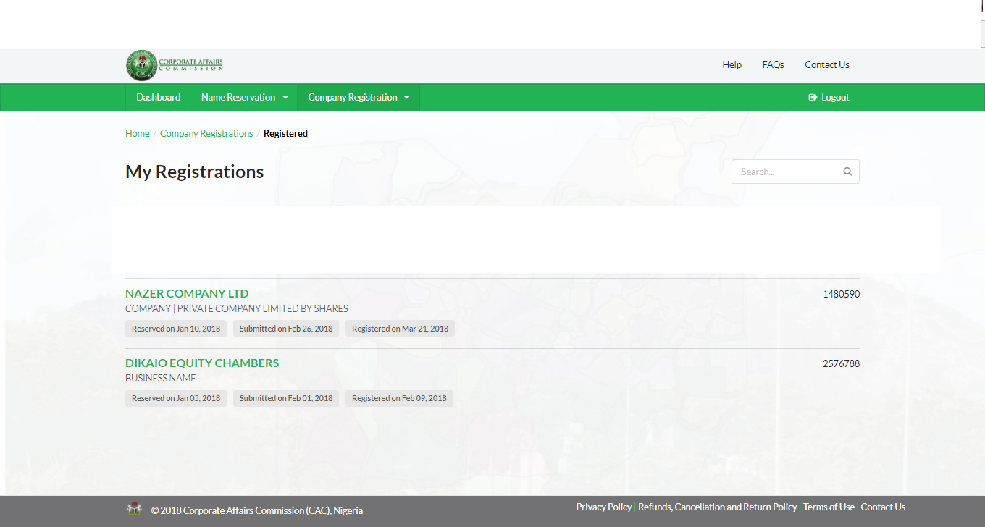

Successfully completed registrations of the above and got the certificates.
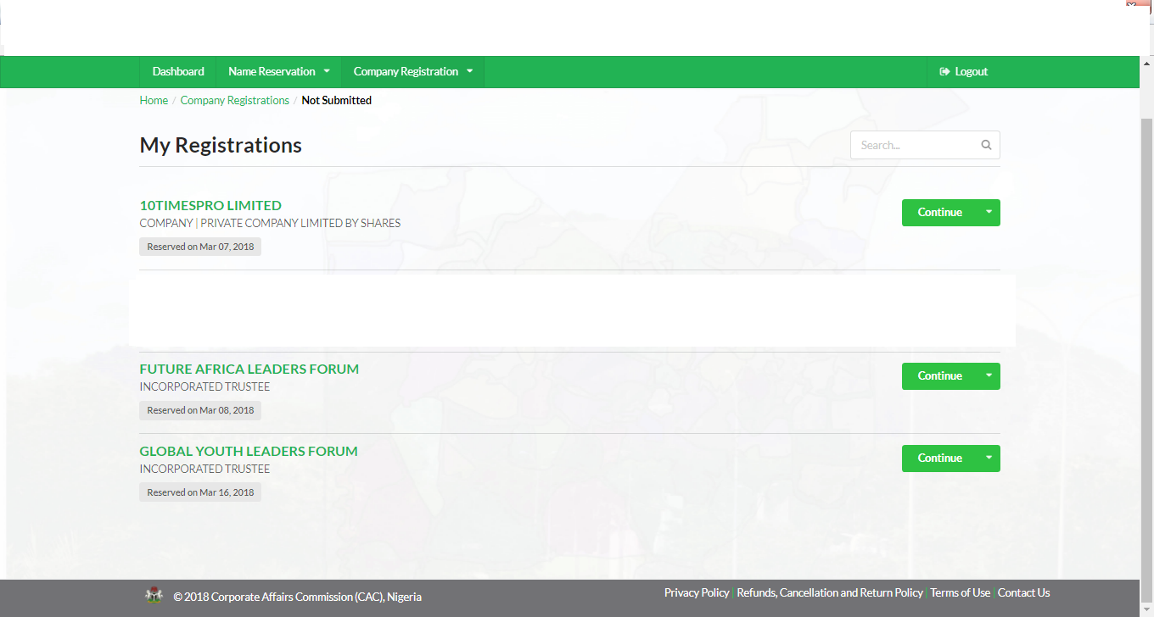
Above shows screen-shots of registrations in process.
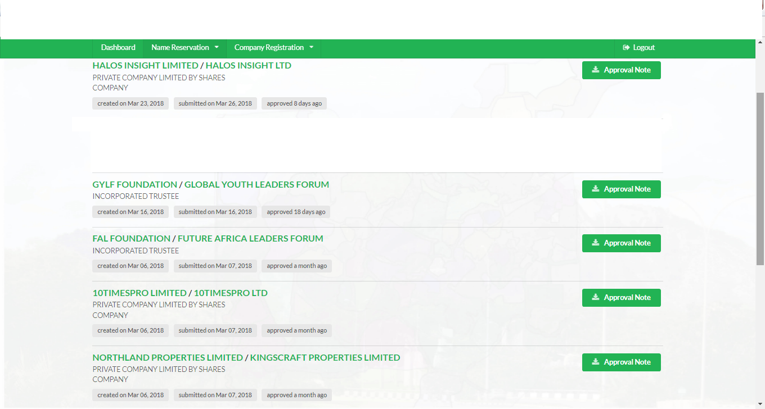
Above shows screen –shots of approved name search and registrations in process.

CHALLENGES
The corporate affairs portal was down and it slowed down our pace with the registrations. Nine(9) out of all the names we submitted were denied by the commission. The names are currently been re-couched. Below shows screen shots of denials: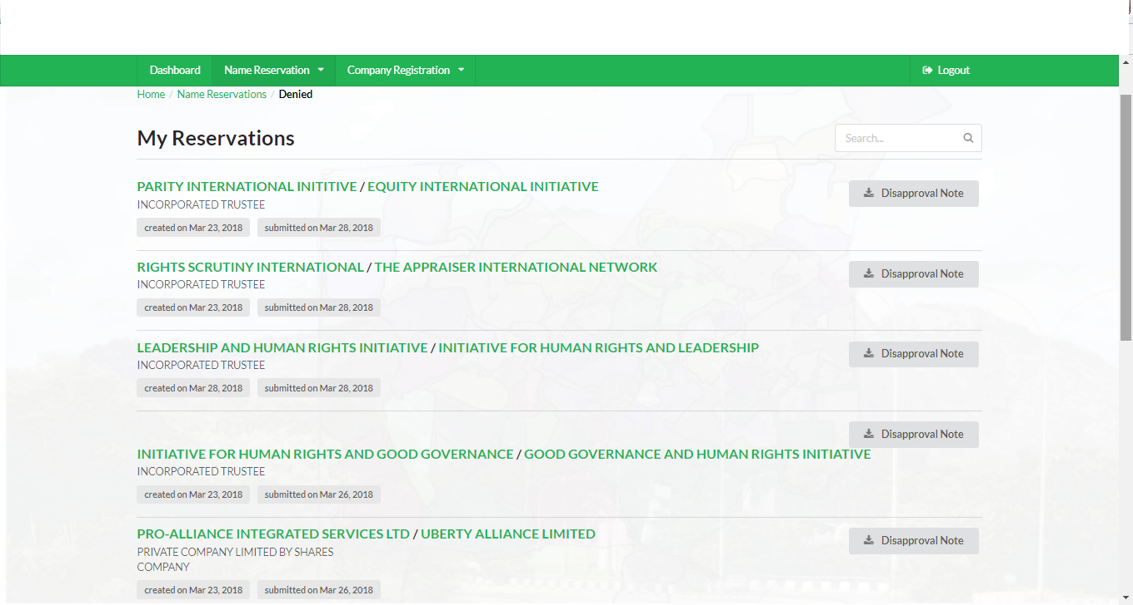
Above shows list of names entered and denied.
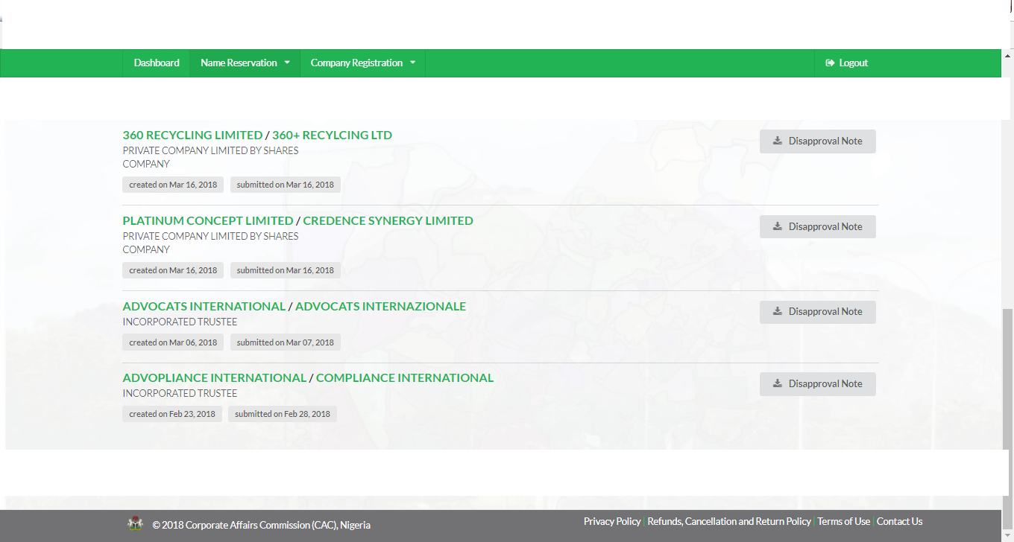
CONCLUSION
We poised with great diligence to ensure that the department set target is achieved and exceeded. We look forward to the next quarter of the year with great hope and enthusiasm.
We are grateful to Pastor Ifeoma Chiemeka for the opportunity to serve in the ministry and equally to Pastor Arinze Emmanuels the Head of Legal Department for his tireless efforts in ensuring our work is thorough and full of excellence.
Thank you.
August Emordi

