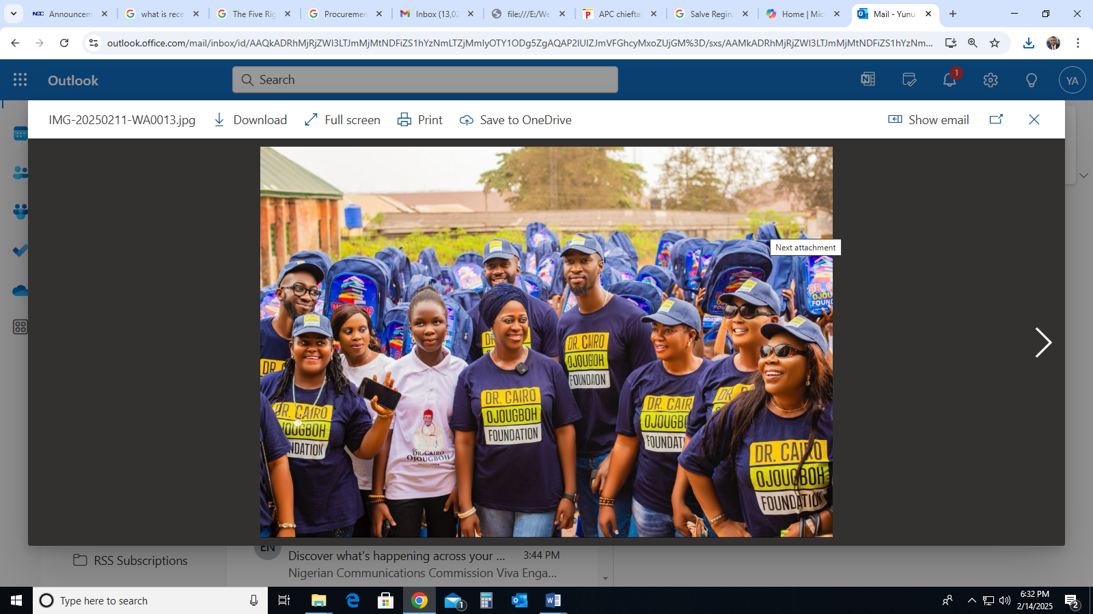
Caption: Mrs. Bose Ojougboh, wife of the Late Dr. Cairo Ojougboh (Centre) flanked by other members of Dr. Cairo Ojougboh Foundation during the outreach programme.
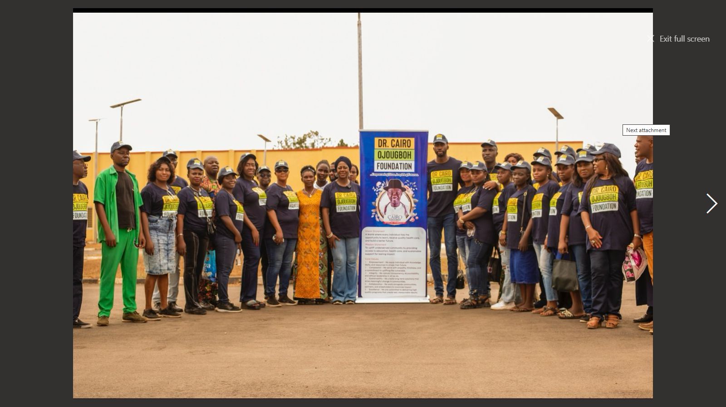
Caption: members of Dr. Cairo Ojougboh Foundation during the outreach programme.

